Flat 206 BUILDING1997 muweelah industrial sharjah(UAE) | Ph : 00971-50-5349905  : 0092-308-4091524  E-mail: ch_muhammadasghar@yahoo.com
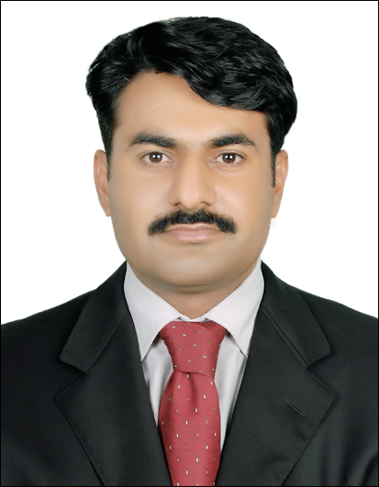 MUHAMMAD ASGHAR
Profile: | I am young, energetic, hardworking and enthusiastic individual believes in snaking up my ladder with honesty and hard work. My technical qualification has equipped me with the ability to perform my job professionally.
Objectives | To join a well-reputed organization and seek experience under extensive training for career development, and will to join such organization where I can apply, the blend of my professional experience, creative ideas and energetic youth. To pursue a challenging career in a prestigious organization that utilizes my capabilities in the best way.
Academic  Record | (Electrical) {TECHNICAL TRAINING CENTER (T.T.C. LAHORE)}  Grade / Div: 1st Passing Year: 2000  Majors Subjects:  - Transmission & Distribution of Electric System.  - AC Machines (Generators, Motors etc)  - DC Machines (Generators, Motors etc)  - Power Plant  - Electric Circuits  - Wring (all kind)  - Estimate and Planning  - Utilization of Electric Power  - Basic & Industrial Electronics  Matriculation: {Govt. High School Hajiwala (BISE Gujarawala)}  Grade / Div: 1st Passing Year: 1996  Majors: Chemistry, Physics, Mathematics and Biology.
Professional Experience | Dubai Electricity And Water Authority (DEWA) UAE  Sr. Technician (Electrical) (11-07-2006 to date)  Jobs Responsibilities.  - Public Dealing.  - Controlling of Medium Voltage (11KV) & Low Voltage (415/240V) line of Electrical Distribution System.  - Installation, Maintenance & Balancing of Transformer.  - Installation & Maintenance of Medium Voltage (11KV) & Low Voltage (415/240V) line of Electrical Distribution System  - Installation, Disconnection & Reconnection of Electric Connection for Domestic, Commercial and Industrial & Agricultural use.  - Design, Planning & Estimate Medium Voltage & Low Voltage (415/240V) Electrical Distribution Lines.  - Installation, Checking & maintenance of Transformers, Single Phase and Three Phase meters, CT Operated Energy Meters, Am meter, Volt meter, capacitors, Resistors & circuit breakers etc  - Use of testing equipments such as Clamp on Meter, Power Analyzer, Digital Multi Meter, Earth Resistance Tester, Power Factor meter, Frequency meters, Megger and other Testing equipments etc.
Computer Skills | Operating System : Dos, Windows, 98, Window XP.VISTA .2000.  Official Tools : MS Word, MS Excel.  Internet : Chat, Email Handling, Web Searching & Browsing.  Others : Printing, Scanning & Fax Operating etc.  Having international computer driving license
Special Skill | Period  Issue Date Expire Date  Having UAE Valid Driving License(LMV) #1122990 26-11-2006 26-11-2016
Personal Information | Name : Muhammad Asghar  Father’s Name : Walayat Khan  Date of Birth : 07-03-1979  Martial Status : married Nationality : Pakistani  Passport# : AA1822632  Issue Date : 02-02-2010  Expire Date : 01-02-2015  Religion : Islam  Domicile : Gujarat(Punjab)  Address(UAE) Flat 206 bldg.1997 muweelah sharjah  Phone No. : 00971-50-5349905, 00971-55-5349905  Email : ch_muhammadasghar@yahoo.com

