MOHAMMAD ZEESHAN

A
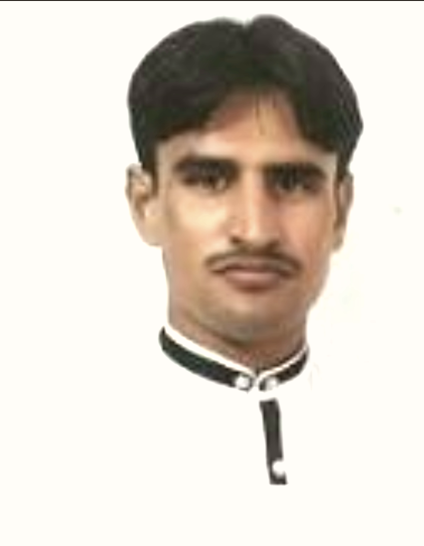
Mob: 0523536936 Sajiddkl@yahoo.com

Objective

- Knowledge is my tool, experience is an asset and struggle is my belief. These are my keys to success for opening the doors of horizons to serve humanity. So I wish to work as team with a leading organization providing good learning opportunity.
Personal Information
Father’s Name : MOHAMMAD SULEMAN SAJID
Date of Birth : 28-08-1993
Passport No : AD5841332
Religion : Islam
Nationality : Pakistani
Language : English , Urdu , Hindi , Punjabi
Qualification

Diploma of Associate Engineer in MECHATRONICS Technology
Experience

- Worked as a Assistant instrument Technician with 2 star contracor in Maple leaf cement From 10 Oct 2014 TO 26 Jan 2015
- Working as a Operator Billet Casting operation in CH-2 with Emirates Global Aluminium Since 02 Feb 2016 TO Till date
Declaration

- I hereby declare that the details are true and accurate to the best of my knowledge and belief

