Umer sharif  @ THE Hague, Netherlands  www.linkedin.com/in/umer-sharif-0651651331  M: +31.651651331  E: umersharif85@gmail.com | Mobile Core Implementation & Performance / IP Technology Consultant | 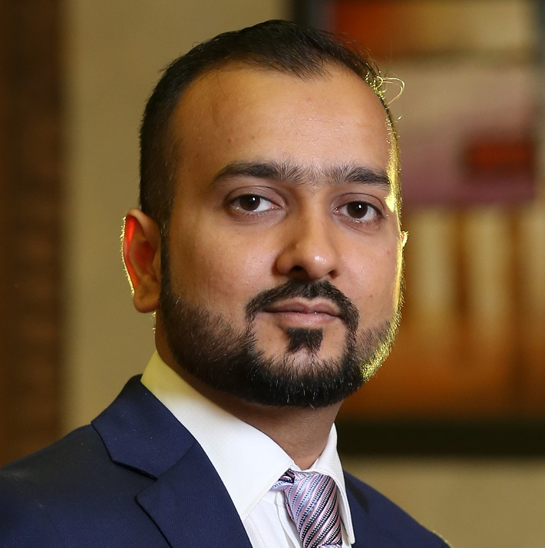

Summary

Enthusiastic, Innovative & Result-oriented Telecom professional working in an agile environment with 9 Years of technical experience in Mobile Core Planning, Optimization and Performance management with a degree of master’s in business administration.

Seeking a challenging position with a technology-driven organization and to work with state of art products/projects in the areas of Network Performance, Implementation, Planning and Optimization in an environment that encourages innovative thinking, recognition, and career development.

I would like to mention that working in the Netherlands for almost 5 years gave me great exposure and learning opportunity. I really like the Dutch working environment and professionalism. This experience motivates me to stay in the Netherlands for long and therefore, I have started to learn Dutch. Currently I am at A1 level.

Specialties

- Mobile Core & IP Networks Fault Analysis
- IMS Core
- GSMA standard & IREG testing
- MVNO Design & Implementation
- Mobile Core (CS/PS) Tooling & Performance analysis
- Mobile Core (CS/PS) Performance Optimization
- Mobile Core (CS/PS) Operations & Network Audits
- Integration/Commissioning & Expansion
- Database Implementation & Configuration
- Project Rollout Coordination
- Implementation Management
- Change Management
- Demand Management
- Project management (Telecom Network Projects)
- Stake Holder and Relationship management

Vendor Expertise

- Cisco Switches & Routers
- Juniper Switches & Routers
- Alcatel – Lucent IMS
- Huawei U2000
- Huawei SGSN/GGSN (USN9810/UGW9811)
- Huawei S-GW / PGW UGW 9811
- Huawei STP SG7000
- SeGW Eudemon FW PGPX-8
- PCRF UPCC/USCDB
- DNS Infoblox

Education

- Master in Business Administration 2010-2013
Institute of Business Management – CBM

- Bachelors of Telecommunications Engineering 2004-2008
National University of Computer and Emerging sciences

Professional Experience

Mobile Core Consultant @ KPN Netherlands – Den Haag

November 2013 - Till date

ACNi IP & 3GPP Designer August 2017 to date
My Role in ACNi Core Development is IP & 3GPP designer. This includes working closely with KPN architecture (CTO) and transforming business and architecture needs in technical designs. I prepare and test Designs and assist ICTM Mobile Data team to implement these designs in the live network.

Major Projects & Achievements
- MVNO Teleena
- CGNAT Replacement
- IPv6 introduction in KPN network
- RFSP (RAT Frequency Selection Priority) & SPID (Subscriber Profile Identifier) project
- Ericsson Baseband Unit integration on KPN Security Gateway

ICTM Mobile Data Engineer - October 2013 – July 2017
My role in KPN is the execution & implementation of IP & Data projects with an in depth understanding of IP/GPRS/UMTS/EPC concepts. Timely delivery of the projects with minimal customer impact is the key to this position.

Roles and Responsibilities:

- Implementation and troubleshooting of Volte in initial stage
- Optimization of PS core KPI’s
- Implementation of MVNOs and Migration to LTE
- Software upgrade and latest patch installation for PS node
- Preparing and Implementation of new EnodeBs on EPC elements.
- Implementation of new Machine to Machine Customers.
- Preparing and executing the Migrations plans for L2/L3 corporate customers from GGSN to UGW platform.
- Implementation & maintenance of new features on PCRF
- Providing Operational Support of Infoblox DNS
- S1-MME/S1-U/S11/S6a/S5-S8 Interface configuration on EPC Nodes
- APN definition & Optimized Routing from SGSN/USN and corresponding definitions on GGSN/UGW.
- USN/UGW Upgrade/Patch implementation/ License Management
- OSPF/BGP definitions for Gn,Gb,Iu,S1-U,Gi, Gx,Gy,AAA,S6a services and interworking for these services between USN/UGW, CE & PE Routers
- Troubleshooting for Mobility Management/Session Management procedures for 2G/3G/4G based on Trace analysis and CHR log files.
- Troubleshooting and Implementation of IPSec/GRE VPN Tunnels for Corporate Customers
- IP network support and problem solving including routing (BGP, MPLS, OSPF, etc...) and switching issues
- Planning roaming solution with different GRx providers
- Issues & Complaints related to Inbound & Outbound Roamers
- Implementation and Testing of New Roaming Partners
- Analysis of Core KPIs like MOC SR, MTC SR, LUP SR, HO SR, MAP SR, CSSR, PDP SR, Attach SR etc.

Major Projects & Achievements

- 4G / LTE Rollout in KPN Network
- Migration of MVNOs (Telfort, Lebara , Lycamobile ) to 4G.
- Migration of MVNO Truphone from Vodaphone to KPN Network
- Introduction of Voice Over LTE and Voice Over WiFi service in KPN Network

Technical Implementation Lead @ Mobilink Cellular Network - Pakistan

November 2008 – October 2013

My role in MOBILINK started with an entry level ICT engineer as it was my first professional working experience. Within 3 years after gaining sound technical knowledge and experience I was promoted to a technical Implementation Lead/Manager. In this role I was involved in Planning , Execution , Implementation , Escalation and Coordination in a Large telecom network operations department. I was responsible for Operations, Optimization, Integration and Expansion , Incident and Process management for smooth and synchronous operation

Roles and Responsibilities:

Responsible for testing and quality control. Working with UAT team to create test cases
- Managing technical support team (team of 7 full time employees) and Incident management team (4 Full time employees)
- Manage the team’s daily activities (support and coordination of service requests and incident management, ensuring high availability for related IT services)
- End-End support, coordination and control of assigned trouble tickets with root-cause analysis
- Evaluate the KPI’s (CSR, LU SR, PSR, CPU Utilization and Availability) through statistical tools and performing network optimization to improve performance for all CS Core systems
- Responsible for several projects including rollouts and upgrades
- Close coordination with Core Network Planning, Optimization and TAC-2 Teams to ensure smooth roll-out of new services & platforms to meet the capacity requirements.
- People management (planning, monitoring, and appraising results, coaching, initiating, and enforcing systems, policies, and procedures)
- Designing priority matrix to address issues as per priority
- Responsible for designing escalation process, communication and coordination process with clients and internal stakeholders.

Planning and executing release schedules

Ensuring successful and smooth release process
- Leading and exploring business growth opportunities
- Strategic and Relationship Management

Major Projects & Achievements

- Commercial Launch of Huawei ATCA VMSC & MGWs
- Commercial Launch of Huawei STPs SG7000 and integration with Live network
- Commercial Launch of Huawei ATCA SGSN/GGSN (U9810/UGW9811)

Certifications & Trainings

- Professional Scrum Master I
- Professional Scrum Product Owner I
- Agile/Scrum training by prowareness
- Training on “Conflict Management– Channelizing the Differences”
- Training on “Achieving through Feedback”

Training on Thinking out of the box/ Creativity

Trainings on effective business communication, time management & personnel strength.

Personal Information

Nationality; Pakistani, moved to Netherlands in 2013
Date of Birth; 21st December1985
Languages; English and Urdu, Learning Dutch

