PERSONAL PROFILE

Dependable, committed, passionate and motivating sales professional with years of experience in sales, sales management, staff training and development. I am a confident communicator and able presenter from sales pitches to departmental presentations. If you are looking for a reliable, resourceful and an ethical professional with good business acumen, who takes pride in building business, brand awareness, and product loyalty through integrity and honesty, I can proudly consider myself as the one.

CURRENT EMPLOYER

British Telecommunication Plc April 2019- till date
Position: Senior Business Manager- BT Enterprise – Mid Market Acquisition

Key Achievements:

- 101.2% achievement against the target in 1st year.
- Highest Q2 and Q3 sales achievement within Mid-Markets for 2019-2020
- Major brand wins in 2019-2020 with strategic importance for BT and wider BT Group.
- 100% target achievement on NPS, with rating at 9.5 out of 10

BT Local Business London (Oct 2007 – April 2019)
Position: Senior Business Manager – Solution Sales

Bringing personal target sales revenues in excess of £1.2 Million per year for Voice, data, Mobility and IP sales collectively

Key Achievements:

- Recognized as a top cloud sales employee in SME for year (2016-2017)- volume sales.
- Awarded Top sales agent (2016-17) in the country for cloud-based telephony services in SME sales
- Awarded Top sales agent (2012-13) for the region.
- Designed, proposed and delivered as a solution architect to some of the leading universities within UK
- Achiever of numerous performance-based awards and incentives

Job Description:

- Targeted on bringing new logos into the business without losing focus in finding opportunities for cross selling for newer revenues and maximizing BT’s technology partnership and displacing competition  .  - Ensuring accurate sales forecast to the business. Develop and implement ideas, using internal commercial insight, data analytic tools and system to generate healthy business pipeline  - 360 sales cycle management from identifying and qualifying customer needs, offer expert advice and recommendations in the subject area, building proposals, leading negotiations leading to the sale of the service.  - Coordinating post sale activities within the department for timely deliverables or make quick decisions using analysis, intuition and expertise in providing a brilliant customer experience | - Devising business strategy with the manager in achieving accurate sales forecast and continuous improvement techniques for the team  - Coaching and mentoring sale staff/ team members on selling techniques and sharing best practices in building high performing cultures  - Collaborating with wider teams like BT marketing team in developing area specific promotions and targeted campaign for brand/product awareness, helping in boosting sales for the region.  - Accurate sales forecasting and building strategic Account development plans
Proficient in

- Cloud Base Telephony Options (Hosted/ Virtualized PBX)

- Data
  - Dedicated Leased lines on different mediums of connectivity
  - Layer 2, Layer 3 point to point setups
  - LAN/WAN/MPLS

- Business continuity & Disaster recovery customer services
  - WAN (Multicast Resilience delivery options)
  - Cloud/ hosted with automatic rerouting technologies

- Mobiles
  - Complete EE and BT portfolio of services
  - Virtual PBX system on mobile networks

- (Traditional) Fixed Line Services
  - PSTN, Feature lines, ISDN2e, ISDN30e, ISDN30 DASS, SIP, Featurenet5000/10000

- On premise Telephone Systems
  - Standard Analogue or Digital TDM, IP based system or hybrid. Trained on Avaya, Mitel, Versatility, SIP,

CNET Direct a division of CNET Networks UK Ltd (Oct-2006 – Oct 2007)

Position: New Business Sales Project: ORACLE
New business sales lead for Oracle and Oracle business partners by analyzing business models to uncover opportunities for front end business applications

Achievements
Winner of Tier 2 Performance Bonus for January 2007
Winner of Tier 1 Performance Bonus for March 2007

Touchstone Communications (26 March, 2002 – 31 June, 2006)

Title: Custer Service Representative Position: Team leader

Recognitions /Awards/Achievements with Touchstone Communications Pvt Ltd

- Winner of CHAIRMANS AWARD for the year 2006
- Winner of “6” Top Dogs awarded by CEO Performance appreciations and numerous perfect attendance certificates awarded by GM and Director Operations.
- Honorary member of Internal Audit team for COPC “Customer Operations Performance Centre” (world’s leading authority on operations management and performance improvement for buyers and providers of customer contact Centre and BPO services)

QUALIFICATION

Graduation
LLB (Hons) - Specialized in Company & Contract Law, Corporate Governance)

Certification
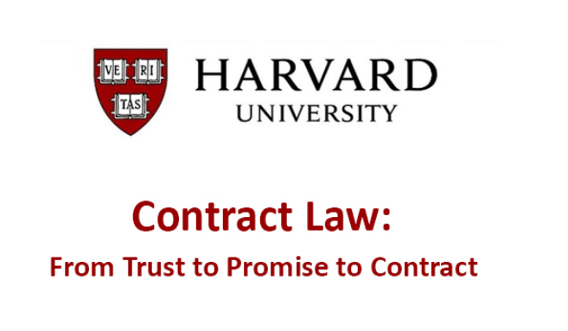 Additional Certification – Business Contracts
- Various IT certifications

TRAINING
- BT Connected leader program
- BT Personal Presence Training
- BT Commercial Acumen; Deal optimization for senior sales professionals
- BT SPIN framework sales training, enhanced selling skills and sales operations

Charities I support

Helping, mentoring and inspiring young people for their future jobs and career journeys

*References can be furnished upon request

